Energy Management in Multi-Source Energy Harvesting IoT System

Neha Garg, Dr. Ritu Garg
National Institute of Technology, Kurukshetra, India

ABSTRACT
To guarantee the uninterrupted operation of an IoT node, various Internet of Things (IoT) systems are composed of low power wireless embedded devices like sensor node. IoT nodes are installed outdoor and indoor with the energy harvesting techniques to prolong the lifetime of the system and for recharging their batteries. Most of the energy harvesting systems harvest the energy from energy sources which are predictable like sunlight and wind speed. However, the energy harvested from sunlight is non-continuous during daytime and zero during nighttime, and the amount of energy harvested from the wind speed is insufficient for continuously powering an IoT node. Thus, to resolve this problem, author proposed an system namely SWEH which harvests energy from sunlight and wind speed. In this work, author assumed that activities (like environment monitoring) of IoT can be performed by various tasks like sensing, processing, communication and so on. Further, alternative tasks are available for same activity which differs in the amount of energy consumption, QoS level and the way in which activity is implemented. Thus, author proposed a scheduling algorithm that selects a subset of tasks from the set of available tasks depending on the amount of energy harvested by SWEH and the outstanding battery. The main aim of the algorithm is to balance the energy production and energy consumption of an IoT node that results in energy neutral system i.e. the energy produced during a particular time frame is greater than or equal to the energy consumed in the same time frame. Results from simulation analysis clearly manifests that proposed SWEH system harvests more amount of energy as compared to amount of energy harvested by a single solar cell or a wind turbine. With the help of simulation results, author also show that algorithm leave the system in energy neutral state at the end of particular time frame.
Keywords: IoT Node, Sunlight, Wind Speed, KL-SUN3W, PIMWEH, Task Scheduling, Energy Neutral, Supercapacitor

INTRODUCTION

Various IoT systems are composed of low power wireless embedded devices, which are installed outdoor and indoor for harvesting energy by using energy harvesting techniques and prolong the lifetime of the IoT system (Haight et al., 2016). An IoT devices consist of various components like processor, Ram, Flash memory, microcontroller, set of sensors and actuators, SD card slot and so on. Each IoT nodes have the capability of monitoring the environmental phenomenon and locally store and process the monitored data. Whenever node detect occurrence of any event then they send the monitored data to the gateway which transmit this data through internet to the remote users. The biggest problem with an IoT node is the finite-capacity batteries. Most of the IoT nodes are powered by the finite-capacity batteries or the supercapacitors to sustain the operation of the IoT nodes. Total energy consumption of IoT node is calculated as the sum of the consumption of each component of the IoT node at each state. The lifetime of IoT node is limited because when the battery charge drops down the threshold value then IoT node stops working and remain in dead state until battery is recharged or replaced. The cost of replacing and maintaining millions of batteries is very high. Nowadays this problem is removed with the help of energy harvesting systems.

Energy harvesting systems harvests the energy from the available natural resources (like sun, wind, water, radio frequencies and so on) and the energy released by the human body (like walking, cycling, breathing and so on) for powering the IoT nodes (Raghunathan et al., 2005). Most commonly used energy harvesting architectures are, 1) Harvest and Use: harvested energy is directly used and 2) Harvest-Store-Use: harvested energy is directly used, and extra energy is stored for further operations (Kansal et al., 2007). The amount of energy harvested by the energy harvesting systems depends on environmental phenomenon, and the harvested energy is uncontrollable and is not continuous. Therefore, to avoid unavailability of IoT node, batteries are required. IoT nodes use the rechargeable batteries that is recharged when energy harvesting system extract more than required amount of energy. When energy harvesting system extracts less than required energy, then these batteries are used by the IoT node for performing their operation. However, in the case when battery capacity is below the threshold value and energy harvested by energy harvesting system is zero, then system remains in the inactive state until energy harvesting system extracts the required amount of energy. In such type of systems, an efficient energy management approach is necessary to infinitely prolong the lifetime of the IoT nodes while performing the operations of the IoT nodes.

In this work, author consider an internet of thing network comprises of IoT nodes for an outdoor application. Author propose an energy harvesting system namely SWEH which harvests energy from multiple sources that are sunlight and the wind speed, and energy production model for estimating maximum amount of energy harvested by SWEH system. Aim of the author is to make system energy neutral, that is, within the given time slot, the amount of energy consumed by IoT node should be greater than or equal to the amount of energy produced by SWEH in such a way that IoT node will have the same amount of battery after given time frame as it had in the beginning of the time frame. Several operations performed by IoT nodes are modeled as tasks; for example, task can be defined as communicating, monitoring, processing, sensing, and transmitting. Some cost is associated with each task, defined as energy required per unit of time. Each IoT node can execute number of tasks with certain cost. When the energy harvested from energy harvesting is insufficient to sustain the IoT node operation, then IoT node perform no operation that’s mean IoT node remain in idle state. To maximize the lifetime, IoT nodes should select the most appropriate task from set of tasks for execution such that IoT nodes work continuously. Based on this model, author proposed a scheduling strategy which is dedicated to finding most appropriate scheduling plan for IoT nodes along a time frame, for instance one hour, such that it maximizes the lifetime of the IoT nodes and leave the system in energy neutral state.

The remaining paper is ordered in following way: Firstly, in section 2 review of the literature is presented, and then section 3 presents the proposed SWEH system and battery charge and discharge model. The proposed SWEH system comprises of a IoT node, photovoltaic cell and wind turbine. In section 4, author discusses the task model which includes scheduling strategy, battery model and the proposed energy neutral plan scheduling algorithm. In section 5 simulation results of algorithm are presented and finally section 6 discusses the conclusion.

Literature review

In recent years, several energy harvesting techniques are introduced for harvesting the energy from environmental resources (Basagni et al., 2013; Gilbert et al., 2008). Most of energy harvesting techniques already presents in literature harvest the energy from sunlight or wind speed. The concept of harvesting energy is reviewed in various papers (Stojčev et al., 2009; Sudevalayam and Kulkarni, 2011; Jayakumar et al., 2014; Babayo et al., 2017). Some of solar light and wind speed energy harvesting systems are Heliomote (Raghunathan et al., 2005), Prometheus (Panatik et al., 2017), Everlast (Panatik et al., 2017) and horizontal and vertical scale wind turbines (El-Sayed et al., 2016) respectively. A drawback of solar cell is that the energy harvested by solar cell is zero during night so solar cells are used during daytime only. Similarly, the energy harvested by wind speed is insufficient for continuous working of an IoT system. Because of this drawback lifetime of the system is also limited and IoT node remain in active state for short duration as long as energy harvested by these harvesters. To overcome this problem, several research works proposed the use of multi-source energy harvester which extracts the energy from more than one source (Weddell et al., 2013; Park et al., 2006). Generally, different energy source used for harvesting energy are categorized on the basis of predictability and controllability. In this work, author use the energy sources which are predictable but uncontrollable. To prolong the lifetime of an IoT node, author used a multi-source energy harvesting system namely SWEH (i.e. Solar and Wind Energy Harvesting) for harvesting energy from sunlight and wind speed.

To yield complete benefit of the energy-harvesting approaches, effective scheduling algorithms must be implemented in energy harvesting systems (Wang and Xiao, 2006). These scheduling algorithms must consider the fixed size of energy storage devices at each sensor node. Several scheduling policies implemented in IoT system are already discussed in literature. Gatzianas et al. (2010) introduces a scheduling approach for energy harvesting system which maximizes the total system utility. Uysal-Biyikoglu et al. (2002) focuses on the problem of minimizing the energy consumption of every node while delivering packets to the sink node by a deadline. The problem is solved by using a lazy scheduling algorithm, which reduces the energy needed for transmitting all packets by lowering the transmission power as much as possible such that each packet must be send before deadline. However, it increases the transmission time of all packets. Djenouri and Balasingham (2011) proposed a flexible method for scheduling tasks which is used to satisfy the energy, delay and reliability requirements by utilizing different priority level queues. Nazir and Hasbullah (2011) proposed a dynamic Sleep Scheduling algorithm, which recognizes each node at two levels for different sleep/wake time according to their traffic load. Main objective of dynamic sleep scheduling algorithm is to minimize the end to end delay and amount of energy required for sending each packet. Moreover, the disadvantage of the algorithm is that each packet must wait for longer period of time because of heavy traffic load. Further, to prolong the lifetime of wireless sensor network, a joint routing and sleep scheduling algorithm was proposed by Liu et al. (2010) which is a collision free algorithm while it does not consider the effect of collisions.

Bergmann et al. (2010) propose a synchronized Control Greedy Sleep algorithm which focuses on increasing the lifetime of the network. The algorithm periodically constructs a tree while considering the residual energy of the node with a vision to balance the energy consumption of the node and it also reduces the possibility of sensor node unavailability. Further, Zhao and Wu (2010) proposed a scheduling method based on the stochastic theory and Hasin and Liu (2004) presented scheduling algorithms based on duty-cycle properties and analyzed their coverage. In Nath and Gibbons (2007) and Tang et al. (2013), two famous Sleep Scheduling algorithms were designed called Connected K- Neighborhood (CKN) algorithm and an improved CKN: Energy Consumed Uniformly-Connected K-Neighborhood (EC-CKN) algorithm respectively. Both Sleep Scheduling algorithms can efficiently sleep the relatively low-power nodes while maintaining both network connectivity and reasonable routing latency. Instead of controlling the transmission power level, the node scheduling schemes power-off or power-down some redundant nodes in the network and therefore can achieve further energy conservation. These algorithms provide energy saving solutions only from the communication perspective (Rodoplu and Meng, 1999; Li and Halpern, 2001).

Recently, researchers concentrated on creating scheduling strategies which will make energy harvesting IoT system an energy neutral system. Some of the scheduling strategies are discussed by Wang and Xiao (2006). Tan et al. (2016) proposed a polynomial time optimal algorithm for finding the energy neutral minimum cost path between the source node (single or multiple) and sink node. Escolar et al. (2014) considers all possible ways of modulating the energy consumption of an IoT node by assuming that alternative tasks are available for same work and each task is characterized on the basis of energy consumption and a quality of service (QoS). The concept is that more than one tasks performs same activity, but with different QoS and cost. They proposed two static algorithms, initial assignment algorithm and re-optimization algorithm, for the assignment of task in each slot. If amount of energy harvested in any slot is greater than energy requirement of tasks selected in that slot, then re-optimization algorithm is implemented for all the rest of slots. Thus, the complexity of algorithm is very high.

In this work, author proposed a more general dynamic algorithm namely Energy-Neutral Plan Scheduling (ENPS) algorithm which focuses on managing the activities of the IoT node and its energy consumption. Further, author assumed that the alternative tasks are available for executing a single activity. The proposed ENPS algorithm focus on the problem of finding the energy neutral assignment of tasks and this assignment is done on the basis of harvested energy and remaining energy in energy storage device (Supercapictor and battery). The aim of the algorithm is to increase the lifetime of an IoT node and to efficiently execute the low-power nodes in realistic conditions.

Model Design
This section describes the proposed SWEH system which harvest energy from multiple sources and the energy consumption model used for IoT node. Author assume that the system is powered by the photovoltaic cell and the wind turbine embedded with super capacitor and rechargeable batteries. The system powered by the SWEH cannot completely depend on the energy produced by sunlight and wind as they are highly dependent on the time of the day and climatic conditions. Thus, author used the super capacitor and batteries as energy buffer to sustain its operation in situations when there is no sunlight and wind. If battery charge drops below the minimum threshold value, then the only option for the IoT node is to remain in inactive state and wait until multiple source energy harvesting system starts producing energy that node requires for performing their operations.
SWEH system extracts energy from the solar light and wind speed and converts it into usable electrical energy for charging the battery and super capacitor. Battery and super capacitor are recharged in following ways: By default, harvested energy is stored in the super capacitor. Secondly, when super capacitor is charged above the maximum threshold value, then harvested energy is stored into rechargeable battery. IoT nodes are powered in following ways: by default, during day time when there is solar light, IoT nodes are powered by the solar energy. Secondly, during night time or cloudy days when there is no solar light, IoT nodes are powered on by super capacitors connected in parallel to the multiple source energy harvesting system. Thirdly, when harvested energy and energy in super capacitor is zero, then IoT nodes are powered on by the rechargeable battery. The amount of energy produced by the photovoltaic cell and wind turbine depends upon various factors like climatic condition, time of the day and the place where photovoltaic cell and wind turbine is placed. Thus, Photovoltaic cell takes solar irradiance D (in W/m²) as input and produce power as output. This solar irradiance is dependent upon the various factors like the geographical location, solar time and climatic conditions. The efficiency is the percentage of the amount of solar light transmitted by photovoltaic cells into usable electric power.
For this work, author use KL-SUN3W (KL solar company) solar panel in their SWEH. This module is made up of 28 mono-crystalline silicon solar cells. By using photovoltaic effect, this solar cell converts energy of photons into electricity. According to manufacturer, maximum efficiency of this solar panel is 12.8%. The dimensions of the KL-SUN3W are 225 ×155 × 77 mm. The maximum output power (P_{mpo}) produced by the KL-SUN3W photovoltaic cell is 3 W. The maximum current (I_{m}) and power voltage (V_{m}) at which photovoltaic cell operate is 0.52 A and 5.82 V respectively. The open circuit voltage and short circuit current of this photovoltaic cell is 7.38 V and 0.55 A. The efficiency (η_{s}) of the photovoltaic cell is computed by using eq. (1), where S_{pc} is the surface area of the photovoltaic cell (in m²) and P_{mpo} is maximum power output produce by the photovoltaic cell (in W).
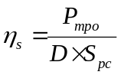
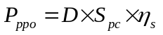
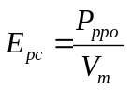
Mathematically, the power (P_{ppo}) (ignoring losses) produced by the photovoltaic cell is computed by using the efficiency (η_{s}), surface area (S_{pc}) of the solar cell and the solar irradiance (D) in the location where solar cell is placed, by using eq. (2). For example, let’s consider daily averaged solar irradiance (D=4.29 KWh/m2) in the Thanesar, Haryana, India in the month of March (Data provided by NASA RETScreen program), then the output power produced by solar cell is 49.90 Wh. Figure 1 (a) shows the daily averaged output power (of all months of the year) produced by solar cell by taking solar irradiance data in Thanesar, Haryana, India and Figure 1 (b) shows the hourly averaged solar irradiance calculated for 5 days of the year. Figure 2 (a) shows the same parameter for some different locations, that is, United Kingdom (Aberdeen). Figure 1 and 2 clearly show that the amount of energy produced by solar cell depends on the geographical location. The amount of energy generated by KL-SUN3W (or any solar cell) is high in the location with low latitude as compare to location with high latitude. For example, in Figure 1 and 2, Thanesar (latitude: 29.9696° N and longitude: 76.8198° E) have more amount of solar irradiance than Aberdeen (latitude: 57.1497° N and longitude: 2.0943° W). The energy produced by the photovoltaic cell is calculated by using eq. (3).
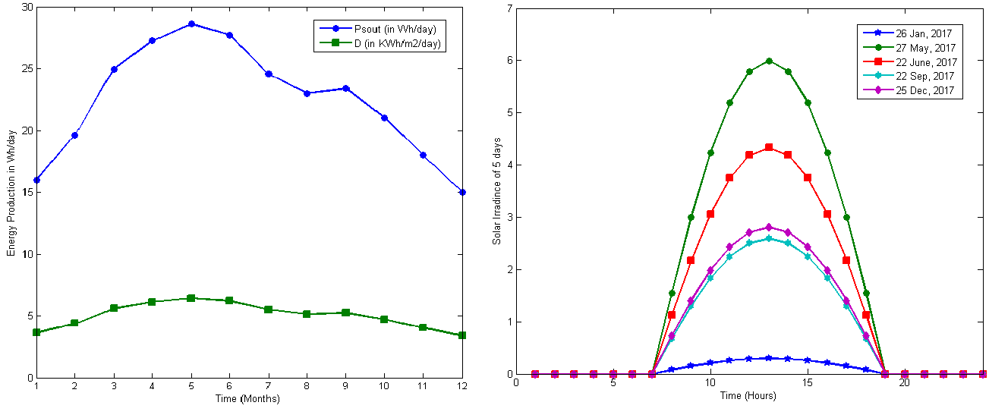
Figure 1. (a) Monthly averaged energy production and solar irradiance of all months of year in Thanesar, Haryana, India and (b) Hourly averaged solar irradiance of five days of the year in Thanesar, Haryana, India
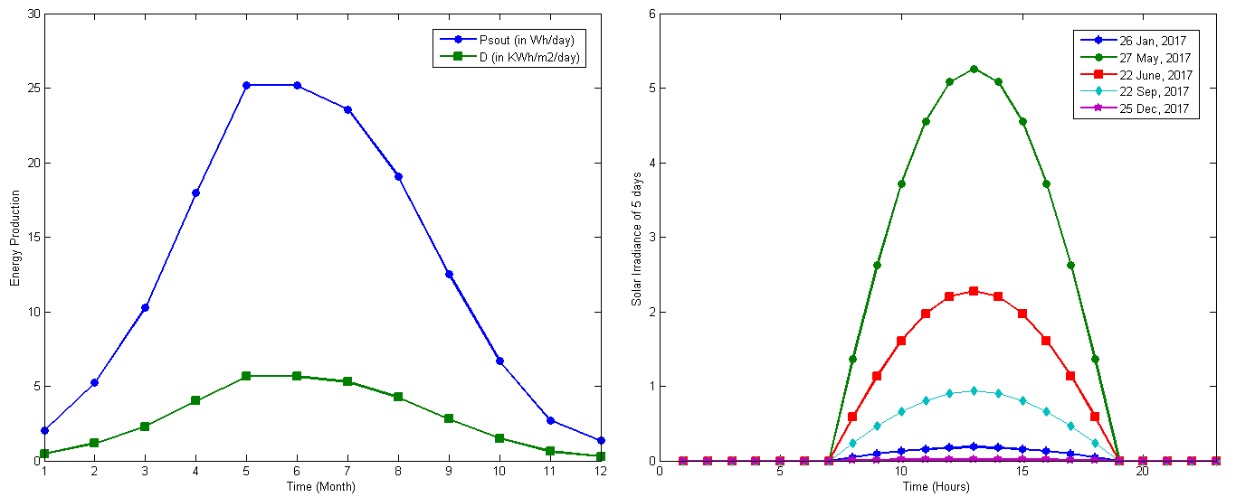
Figure 2. (a) Monthly averaged energy production and solar irradiance of all months of year in Aberdeen, United Kingdom and (b) Hourly averaged solar irradiance of five days of the year in Aberdeen, United Kingdom
Author compute the value of average energy produced by the photovoltaic cell during a period of time by using solar radiance absorbed during that period of time. The instantaneous solar irradiance D(t), in any geographic location on the earth, at a time t ϵ [0,23] is computed by using the correlation factor. Correlation factor depends on the current time, solar time and the climatic condition at that moment. For example, at the time (00:00 or 02:00) when there is no sunlight then the energy produced by the photovoltaic cell is zero. Thus, the instantaneous solar irradiance D(t) is computed by using solar zenith angle(θ_{z}) (Jacobson, 2005; Hartmann, 1994), as shown in eq. (4). Zenith angle, the angle between the center of sun’s disc and the vertical axis of the earth surface, is calculated by using eq. (5). In eq. (5), γ is the local latitude of the geographic location where solar cell is placed; β is the solar declination angle which is computed by using eq. (6) (Cooper, 1969) and h is the hour angle. In eq. (6), d is the day of the year beginning with d=1where d ∈ [1, 365]. The solar hour angle (h) is an expression of time and is computed by using eq. (7), where t is the solar time with the fact that sun shift approximately 15º after each hour. Finally, the estimated hourly averaged solar energy production is calculated by using eq. (8). Figure 1 (b) shows the hourly averaged solar irradiance D(t) for some days of year assuming the values of daily average solar irradiance of 0.34, 6.92, 5.00, 2.93 and 3.24 KWh/m²/day for January, May, June, September, and December, respectively (Data provided by NASA RETScreen Program). Figure 2 (b) shows the hourly averaged solar irradiance D(t) for same days but in different location. Figure 1 and 2 clearly show that the solar radiance computed with the help of zenith angle is also depend on the location.
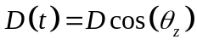
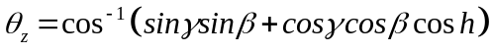
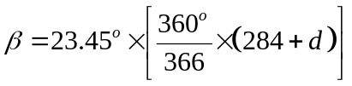
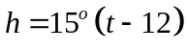
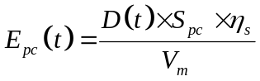
PIMWEH (Jung, 2015) is a piezoelectric impact-based micro wind energy harvester which harvest energy from the wind speed. In this harvester, reverse piezoelectric effect is used for producing electricity from mechanical strain. Author considered this harvester as promising option for their SWEH system. This harvester uses a small wind turbine with 4.5 cm radius and uses an impact stick to strike the cantilever beam. The wind turbine delivers a maximum efficiency of 34.1%. Tektronix DPO-4054B oscilloscope is used as a voltmeter in PIMWEH, and AR856, SMART SENSOR was used as an air flow meter for measuring the wind speed. At 11 KΩ resistive loads 3.3 V pure DC voltage is generated. In this harvester, firstly wind speed is converted into mechanical wind turbine power by using wind turbine. After that, mechanical wind turbine output power is converted into AC electrical power by using PZT with efficiency of 26.1%. LTC3588-1 converts the electrical AC power into DC power, with efficiency of 35.7%. The overall experimental efficiency of the wind energy harvester is 3.2%.
The power output (P_{wpo}) produced by the PIMWEH is computed by using eq. (9), where η_{w} is the efficiency of the PIMWEH, ρ is the air mass density (in Kg/m3), S_{wt} is the turbine area and v is the wind speed which is converted into electricity (in m³). The air mass density is calculated at 1 atmospheric pressure by using an online calculator. Surface area of the wind turbine is computed by using eq. (10), where R is the radius of the turbine. For example, let’s take the daily average wind speed (W_{da} = 3.70 m/s) in Thanesar Haryana, India in March, then the average output power produced by PIMWEH is 6.13 mW. Figure 3 (a) shows the daily averaged power output (for all months of the year) produced by PIMWEH by taking monthly averaged wind speed in Thanesar, Haryana, India as input.
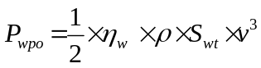
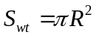
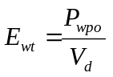
Further, author calculate the value of average energy produced by the PIMWEH during a period of time by using wind speed during that period of time. The instantaneous wind speed Ws(t), in any geographic location on the earth, at any time t ϵ [0,23] is computed by using the correlation factor which is dependent on the current time, solar time and the climatic condition at that moment. There are many equations for calculating the instantaneous wind speed, dependent on the statics available to us. If daily averaged wind speed and daily maximum and minimum wind speed is available then eq. (12) (Guo et al., 2013) is used for computing the wind speed at time t. In eq. (12), W_{s}(t) is the wind speed at time t, t∈ [0,23], W_{da} is the daily averaged wind speed, W_{dmax} is the maximum wind speed in the day and W_{dmin} is the minimum wind speed in the day. The hourly averaged wind energy produced is calculated by using eq. (13). The hourly averaged wind speed is computed using eq. (12) for some days of the year in Thanesar, Haryana, India. Figure 3 (b) displays the hourly averaged wind speed (W_{s}(t)) for five days of the year assuming the values of daily average wind speed of 3.60, 3.10, 2.95, 2.60 and 4.15 m/s for January, May, June, September, and December, respectively (Data provided by NASA RETScreen program). Finally, the total hourly averaged energy produced by SWEH system is calculated by adding the amount of energy harvested by the solar cell and the wind turbine (ignoring loses), by using eq. (14).
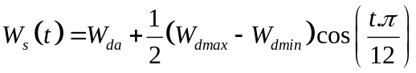
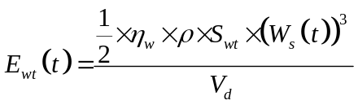
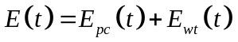
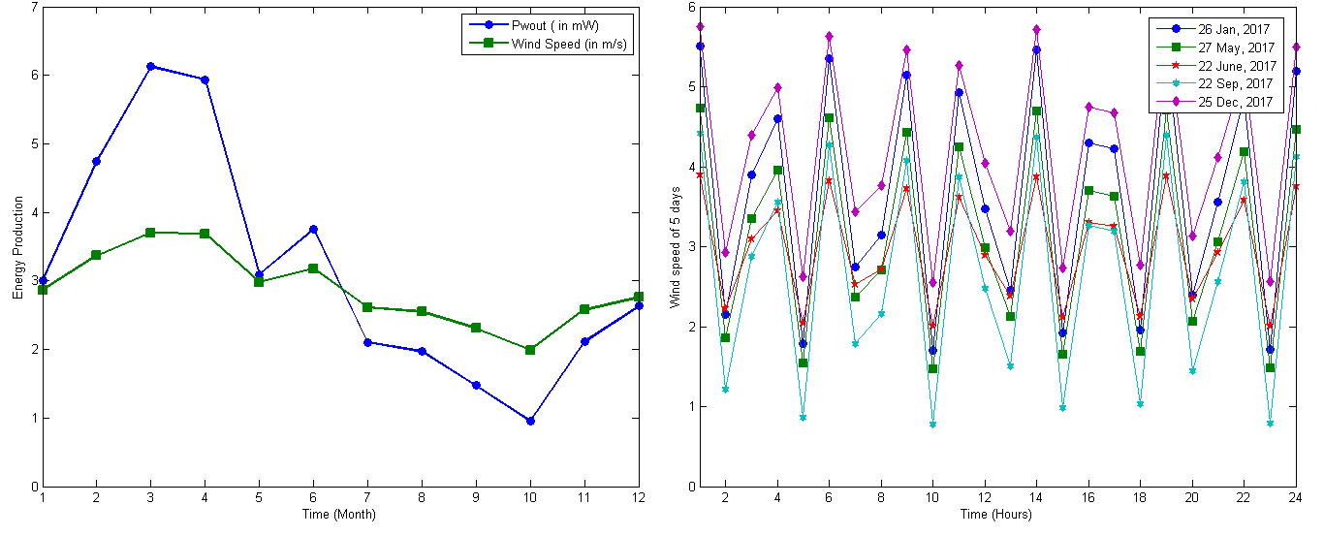
Figure 3. (a) Monthly averaged energy production and wind speed of all months of year in Thanesar, Haryana, India and (b) Hourly averaged wind speed of five days of the year in Thanesar, Haryana, India
The hourly averaged solar call power output and PIMWEH power output for some days of year in Thanesar, Haryana, India is shown in Figure 4. Figure 4 (a) shows the hourly averaged power output produced by KL-SUN3W for some days of the year (data provided by NASA program: RETScreen). Similarly Figure 4 (b) displays hourly averaged power output produced by PIMWEH. Wind power output is very less as compare to solar power output for same five days as shown in Figure 4. PIMWEH may be produce less amount of power output but it produces power for those hours when solar power output is zero. The power output of the KL-SUN3W and PIMWEH are combined, so that more amount of energy is harvested. Figure 5 (a) shows the total power output produced by SWEH system in January and Figure 5 (b) shows the total power output produced by SWEH in December. Figure 5 clearly show the increase in total power produced by SWEH system. SWEH also produces power before the sunrise and after the sunset. With the increase in output power and availability of power for every hour, the lifetime of IoT node will also increase.
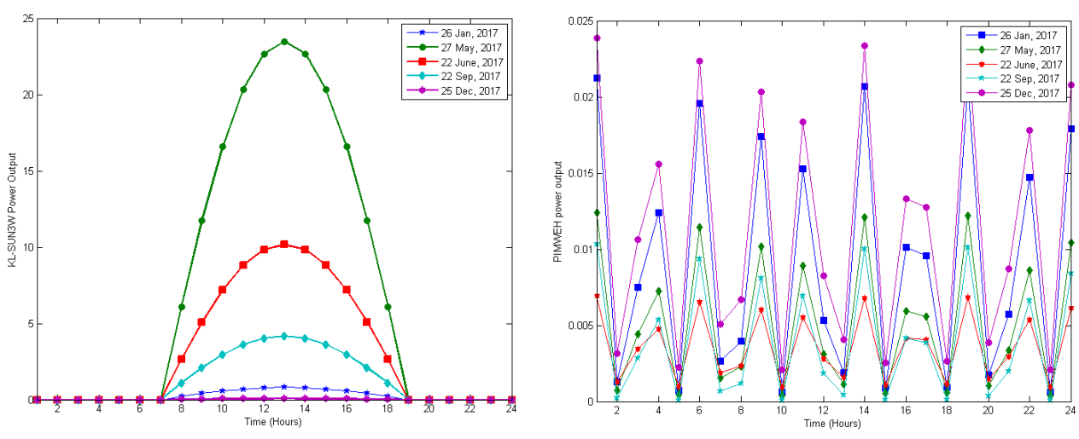
Figure 4. (a) Hourly averaged power output produced by KL-SUN3W for five days of the year in Thanesar, Haryana, India and (b) Hourly averaged power output produced by PIMWEH for five days of the year in Thanesar, Haryana, India
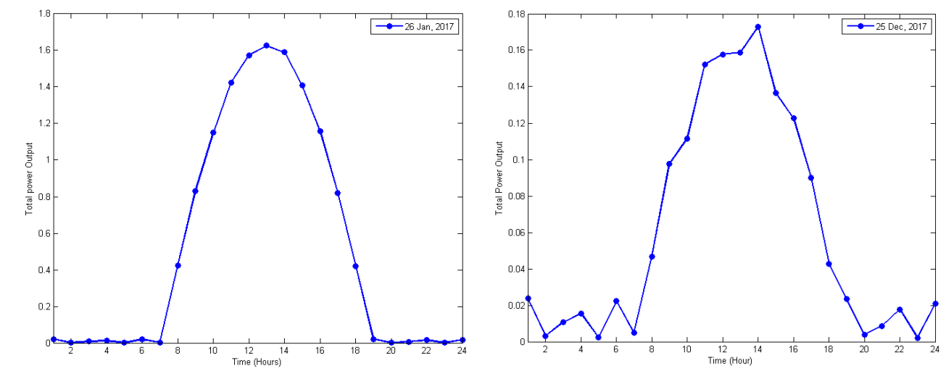
Figure 5. (a) Total Power Output produced by SWEH on 26 January, 2017 and (b) Total power output produced by SWEH on 25 December, 2017
Various IoT node platforms are available in market like Raspberry P1, Arduino (Uno), MicaZ, TelosB, Iris, Cricket, Lotus. Vujovic and Maksimovic (2014) compare the performance of Raspberry PI with other platform based on size, power and cost, and conclude that the advantages of Raspberry PI, such that its flexibility, providing access to internet and coupling with Wi-Fi makes Raspberry PI more suitable for the IoT applications. Thus, author connect photovoltaic cell and PIMWEH to the Raspberry PI 2 model B, an open source platform. Raspberry PI 2 Model B is a small, cheap, powerful computer board introduced in 2016. The Raspberry PI 2 model B board consist of graphic chips, Broadcom BCM2836 processor that support large set of instructions, Raspbian (Linux based) operating system, 1 GB RAM, 4 USB interface for other external devices and one memory card slot. Raspberry is powered by micro USB connector and internet is accessed by USB dongle (Bluetooth, Wi-Fi) or by Ethernet. The Raspberry PI 2 model B works on the 5V 1A battery which is provided through USB port. The dimensions of the Raspberry PI 2 model B are 86 ×56 ×20 mm. It works in four modes that are Shutdown mode, run mode, dormant mode and standby mode. In run mode, all the functionalities are available and CPU is powered on. In standby mode, the power supply is on but some parts of CPU are shut down. In this mode, CPU can be woken up by sending interrupt. In shut down mode, power supply is off. In dormant mode, the CPU is powered down and all caches are left powered on. The basic requirement for the power supply of Raspberry PI 2 model B is that it supply a regulated 5V DC (direct current) and can supply a current of up to 700mA. If author use a power supply with more than 5V then they have to use voltage regulator to drop the voltage to 5V. Author power the Raspberry PI 2 model B by using LiPo battery whose voltage varies from 3.7V to 4.2V. The battery voltage is low so that’s why a boost regulator with battery is used by the author.
Power Consumption Model
In this subsection, author present an energy consumption model of the Raspberry PI 2 model B. As discussed above, batteries are recharged by the multiple source energy harvesting system. On the other hand, batteries are drained with time depending upon the energy consumed by the hardware components in each state. The Raspberry PI 2 model B is connected to a LiPo battery with 3.7 V nominal voltages. To compute the time taken by battery for discharging depends on two factors: first is the battery capacity (B) and second is the current draw required for working of an application. Let’s consider the amount of energy produced by harvesting system is zero, and then the discharge time of the battery is given by using eq. (15). For example, assume capacity of the battery is 2500 mAh, and application required current draw of 200 mA. The time taken by battery for completely discharging is 12.5 hours. Note however the current draw required by any application is not constant, it depends on the requirement of the application along with time. Similarly, time taken for completely charging the battery depends on the two factors: first the capacity of the battery and second is the energy produced by the harvesting system. Let assume that the energy consumption is zero and battery is recharged by the energy harvesting system, then charging time of battery is computed by using eq. (16). For example, assume capacity of the battery is 2500 mAh and the energy produced by the harvesting system is 25 mA then time taken by battery for completely charging is 100 h. However, note that the energy produced by the harvesting system depends on the geographical location, climatic condition and solar time.
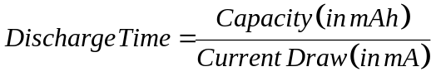
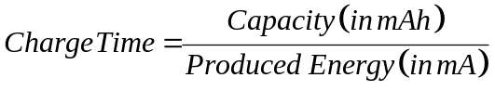
To explain how battery exhausts, author assume three applications, which require 25, 40, and 60 mA current draw respectively and battery of capacity 2500 mAh. Figure 6 (a) show the discharge curves for every current draw on the left side. In this system, battery is charged by the energy extracted by SWEH. Figure 6 (b) displays the time (in hours) required for completely charging the batteries of capacity 2500 and 3500 mAh assuming that energy is produced in Thanesar, Haryana, India.
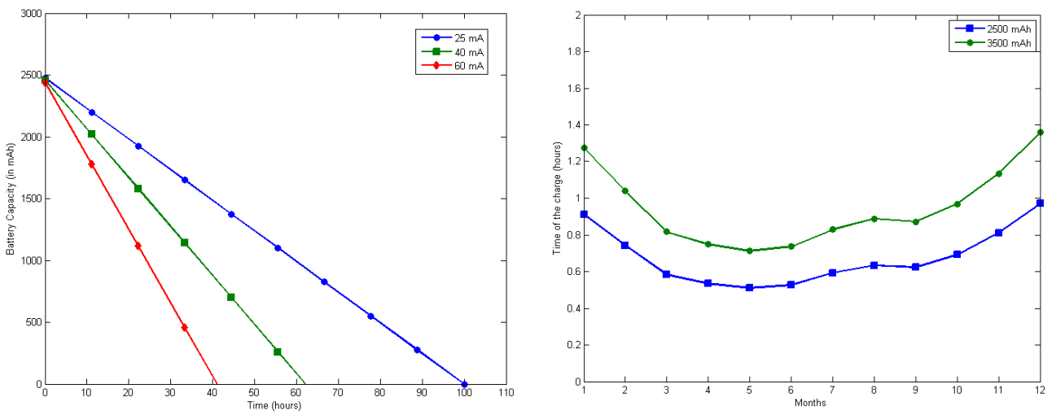
Figure 6. (a) Battery discharge curve and (b) Battery charge curve
TASK SCHEDULING SCHEME
An IoT node is modeled as an automation system that executes a subset of the predefined tasks τ = {T₀, T₁, T₂ …T_{n}}. Task is any activity which is performed by an IoT node. For example, IoT node can work as a simple sensor node which repeatedly executes the following task: sensing, sampling, processing and so on. Several alternatives may be available for the implementations of the same activity which may be differ in the kind of the specific activity performed. For example, an application that has to sense and transmit data to the gateway. Then an IoT node can implement this in two different ways, first implementation is to transmit the sensed data and second implementation is to store and transmit the sensed data. In above case, second implementation requires more energy. That’s why several alternatives of the same activity are considered to meet the energy neutrality constraint of the energy harvesting system. Several implementations of task may also depend on various constraints like cost, quality, feasibility, time and so on, but author consider only cost constraint in this work. T= {t, e, c}, represent a task where t is the time taken to execute the task, e is the total time in which task should be executed (e > t) and c is the cost of executing the task per unit of the time (Escolar et al., 2014). Here cost means the energy consumed by a node for executing the task. When there is no task for the execution then a special task T_{o} is executed by an IoT node. The execution time and total time of execution is not defined for the special task T_{o} and w_{o} is the cost of executing the special task per unit time. Energy consumption is very low when ideal task is executed by the IoT node. Tasks of the node are characterized such that tasks are schedulable and a plan should exist for a subset of the tasks such that while executing this plan each task should execute as indicated by their time of execution. To save the energy, execution time of each task in plan should be small so that node spends more time in the performing special task. A plan (Plan_{i}) is considered as the collection of the tasks. The energy consumption of node executing plan Plan_{i} is calculated by using eq. (17). In eq. (17), first sum calculates amount of energy consumed by node while executing all tasks except special task and second sum calculate amount of energy consumed by node while executing the special task in remaining time. For example, consider two tasks: T₁= (5, 20, 3) and T₁= (7, 20, 6), then the plan executing this task is represented as Plan_{i}= {T₁, T₂, T_{o}}. The amount of energy consumed in executing this plan is 1.25 (calculated by using eq. (17), considering the cost of executing special task T_{o} is 2.
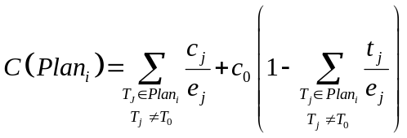
Scheduling Strategy
In this scheduling model, firstly whole-time frame is divided into n number of slots, time period of each slot is calculated by using eq. (18). In each slot, firstly the most efficient plan is assigned to each slot. At the start of each slot, author compared the amount of energy harvested in the previous slot with the cost of the most efficient plan. If the cost of efficient plan and harvested energy are equal, then that plan is assigned to that slot. If harvested energy is more as compared to cost of the most efficient plan, then the plan with high cost but less than the harvest energy is assigned o that slot or if harvested energy is less as compare to the cost of efficient plan the then plan which has low cost as compare to harvested energy is assigned to that slot. If energy produced by harvesting system is zero or very low, then plan is executed by using battery charge and if harvested energy and battery charge is zero then the system remains in non-working state until energy is harvested or battery is recharged. In short, in this scheduling model, tasks are assigned to the node on the basis of harvested energy and residual battery so that node remains in working state as long as possible.
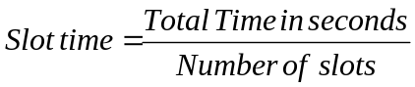
Battery Model
This subsection explains how battery is charged from the energy produced by SWEH system. IoT Node connected to SWEH system utilizes the energy harvested from sunlight and wind speed for the executing tasks and recharging the battery. Thus, the battery level at any time depends on the sunlight and wind speed at that time. Here, multiple source energy harvesting system works as producer which produce energy and an IoT node work as consumer which consumes the energy. EP(s) is the energy produced by harvesting system and EC(s) is the amount of energy consumed by a node in a slot s. B(s) represent the capacity of battery at the end of the slot s and ϑ is recharging efficiency of battery. The rectifier function used in this work is defined as follows:
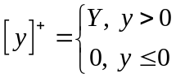
The battery level at end of each slot s is calculated by using the rectifier function. Battery level at each slot s depend on the battery level of the previous slot (s-1) and energy produced and consumed in slot s. In eq. (20), second term calculate the energy produced by the harvesting but not consumed by the IoT node, that’s mean the energy used for recharging the battery, and third term calculate the battery used by the node in slot s. Lifetime of an IoT node is infinite if the energy produced in a particular time frame is greater than or equal to the energy consumed in same time frame. In this work author consider full one day as time period, author try to make this system energy neutral with equal battery level at start of day (00:00 am) and end of the day (23:00).
Energy Neutral Plan Scheduling Algorithm
A plan is scheduled to node which is defined by the subset of tasks in τ. A set of x plans which implement the same work is available for every node and algorithm has to select one plan from that set of plans for execution. For example, two or more plans may implement the same activity with different duty cycles and different costs. All the plans are arranged in the ascending order on the basis of cost. Two plans are equal if and only if all the tasks of both plans are equal. Two tasks T1 and T2 are equal if and only if t₁ = t₂, e₁ = e₂ and c₁ = c₂. Author calculates the energy requirement of node for executing the plan Plan_{i} by using eq. (17). The main aim of this algorithm is to select one plan from set of plans which implement the required functionality with minimum cost and leave the system in the energy neutral state. In this work, author consider one day of 24 hours as a time frame, as author already discussed in above section. This time frame is divided into n number of slot and time period of each slot is calculated by using eq. (18). The algorithm selects the energy neutral plan for each slot s, corresponding to the cost of the plan Plan_{i}. B(s) represent the battery level at the end of slot s. Author assume that if the battery at any slot j is tending to charge above the Bmax, then the capacity of battery remains Bmax in that slot. Likewise, if battery discharges below Bmin, then the capacity of battery will remain Bmin at the end of slot. Let us consider P[] vector which contain all the plans. Author consider whole day of 24 h as a time frame and divide it into n slots. Let consider another array S[] which contain the plan scheduled to the slot s and C(s) represents amount of energy consumed by the node in slot s.
Algorithm 1: Energy Neutral Plan Scheduling Algorithm (ENPS)
Input: P[ ]: Scheduling Plan Vector
Ensure: S[ ]: vector containing plan assigned to slots.
S[s] = P[i] ∀s

Case 1: if (EP(s-1) > C(P[i]) \\Upgrade to high cost plan (Upgrade Function)
m=i
While(m+1<Number_of_plans && EP[s-1]>=EC[m+1])
S[s] = P[m+1]
m++

Case 2: if (EP(s-1) < C(P[i]) \\Downgrade to low cost plan (Downgrade Function)
m=i
While(m-1>0 && EP[s-1]<=EC[m-1])
S[s] = P[m-1]
m--
Case 3: if (EP(s-1) ≅ C(P[i])
Execute the plan
Compute Battery level
The pseudo-code of this algorithm which schedule energy neutral plan to each slot is presented in Algorithm 1. Initially, Algorithm 1 assign the plan Plan_{i} (most efficient plan) to all the slots. Algorithm 1 check the energy neutral constraint, after assigning the most efficient plan, by comparing energy produced in the previous slot and the energy consumption of the initially assigned plan. While executing algorithm 1, two cases occur: (1) If harvested energy is greater than the energy consumption then algorithm executes the 1st case and find the another plan from set of plans with the next higher consumption and this process continues until the best assignment is selected for that slot.; (2) If harvested energy is less than the energy consumption then algorithm executes the 2nd case and find the another plan from set of plan with the next lower consumption and this process continues until the best assignment is selected for that slot. At the end of each slot, battery level is computed which is used when harvested energy is zero. The algorithm selects the lowest cost plan for the slot when the amount of harvested energy is very low and drains the battery. The complexity of proposed plan scheduling algorithm is O(n) in worst case, where n is the number of plans.
SIMULATION ANALYSIS AND RESULT
To evaluate the proposed algorithm, number of simulation experiments have been performed using MATLAB. Time frame of 24 hours is divided into 288 slots. Duration of each slot is 300 seconds. To calculate the energy produced by SWEH, author consider the monthly averaged solar irradiance and monthly averaged wind speed in Thanesar, Haryana, India (Latitude: 29.96). Solar Irradiance (D) is: 3.57, 4.38, 5.58, 6.0, 6.3, 6.1, 5.4, 5.13, 5.22, 4.70, 4.01, 3.35 KWh/m2/day and wind speed is: 2.86, 3.36, 3.69, 3.68, 2.97, 3.17, 2.60, 2.54, 2.30, 1.98, 2.57, 2.75 m/s (data provided by NASA program: RETScreen) for all months of 2017 year. The amount of energy harvested by SWEH system at time t is calculated by using the equations described in section 3. Then, equally distributed the energy produced by harvesting system among all slots of an hour. In order to produce more real simulation results, author also considered sunrise and sunset slot for each month. A battery with maximum capacity B_{max} of 2500 mAh and minimum capacity B_{min} of 1950 mAh is considered. Initial capacity of battery is 2000 mAh (at slot 0). To validate that SWEH system is energy neutral system, author prove that the battery level at last slot (288) should be greater than or equal to the batter level at first slot (0). Author defined six different set of tasks (τ₁, τ₂, τ₃ … τ₆). The description of these six sets of tasks is as follows: τ₁ = {(2, 5, 10), (1, 5, 15), (1, 5, 8)}, τ₂ = {(1, 10, 3), (1, 10,5), (1, 10, 5), (1, 10, 7)}, τ₃ = {(5, 15, 10)}, τ₄ = {(2, 20, 3), (2, 20, 4)}, τ₅ = {(20, 30, 10} and τ₆ = {(26, 30, 2)}. Further, author assumed the set of six plans corresponding to above defined set of tasks and cost of each plan per unit time (computed by using eq. (17)) is: 7.0, 3.2, 2.3, 1.75, 1.0, and 0.33. Finally, algorithm is implemented considering the monthly averaged energy produced by SWEH system for all months of the year and the results are shown in Figure 7.
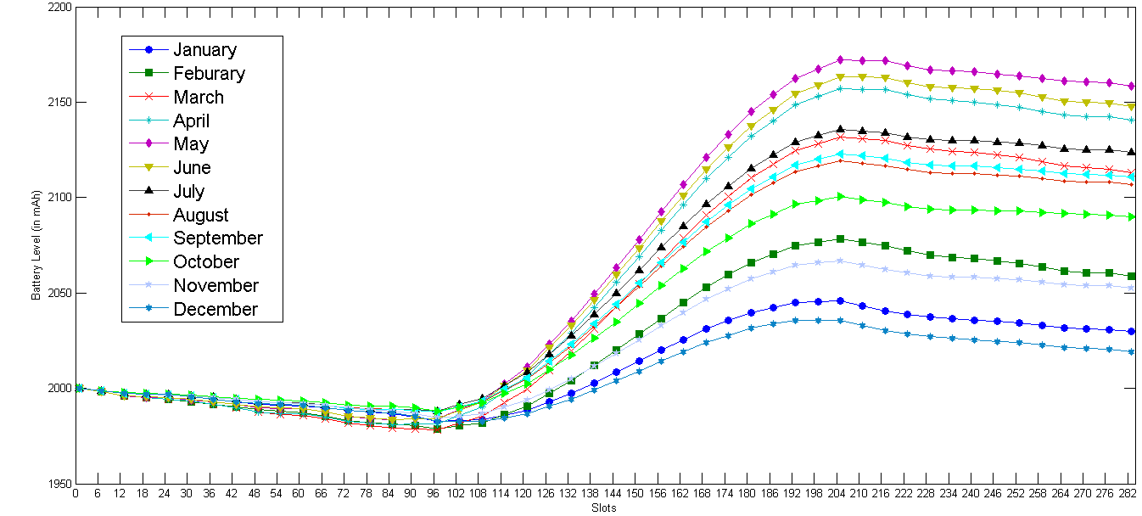
Figure 7. Battery level at the start of each slot for all months of year
Figure 7 clearly shows Battery capacity is always greater than the initial capacity of the battery at last slot. The algorithm finds scheduling of plans to each slot such that the system remains energy-neutral for each day corresponding to each month of the year. Figure 7 clearly shows the relationship between the energy produced by harvesting system and capacity of battery: larger the amount of energy produced by harvesting system, higher capacity of battery is achieved at the sunset slot and the lowest capacity of battery is before sunrise slot. As shown in figure 7, the maximum capacity of battery i.e., approximately 2170 mAh is achieved in May and, minimum capacity of battery i.e., approximately 1978 mAh is achieved in March. Further, Figure 8 (a) shows the plans assigned to each slot by algorithm in January and June month and similarly Figure 8 (b) shows the plans assigned to each slot in December and July. Assignment of plan to each slot is done on the basis of energy produced and consumed in that slot. Figure 8 clearly shows that after the sun rise slot and before the sunset slot, the plan with the highest cost is assigned to each slot.
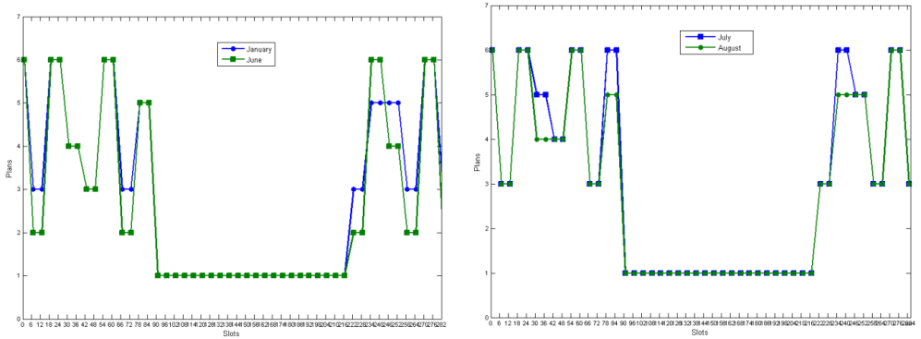
Figure 8 (a) Plan number assigned to each slot in January and June and (b) Plan number assigned to each slot in July and August
CONCLUSION
Energy Harvesting Systems are the promising solutions to infinitely increase the lifetime of the IoT network, since it naturally extracts energy from their surroundings. Most of the IoT networks use the energy harvesters which harvest energy from sunlight and wind. A major limitation of these harvesters is that they support only single type of energy source and are beneficial only in those areas where this energy source is accessible. To overcome this problem, author proposed SWEH system which harvest energy from sunlight and wind. The energy harvested by the SWEH systems is uncontrollable, that’s why, author proposed a plan scheduling algorithm which balances the energy production and energy consumption in order to infinitely increase the lifetime of system while maintaining the energy neutrality of the system. Assuming that there exist alternative plans which differ in cost. The algorithm aims at assigning the plan to each slot on the basis of energy production and consumption in that slot and leaves the system in energy-neutral state at the end of time frame. Further, author evaluate the proposed algorithm with the help of simulation and results show that how a valid assignment of plan to each slot, leaves the system in energy neutral state.
REFERENCES
Babayo, A. A., Anisi, M. H., & Ali, I. (2017). A review on energy management schemes in energy harvesting wireless sensor networks. Renewable and Sustainable Energy Reviews, 76, 1176-1184.
Basagni, S., Naderi, M. Y., Petrioli, C., & Spenza, D. (2013). Wireless sensor networks with energy harvesting. Mobile Ad Hoc Networking: Cutting Edge Directions, Second Edition, 701-736.
Bergmann, G., Molnár, M., Gönczy, L., & Cousin, B. (2010, March). Optimal period length for the CGS sensor network scheduling algorithm. In Networking and Services (ICNS), 2010 Sixth International Conference on (pp. 192-199). IEEE.
Cooper, P. I. (1969). The absorption of radiation in solar stills. Solar energy, 12(3), 333-346.
Djenouri, D., & Balasingham, I. (2011). Traffic-differentiation-based modular QoS localized routing for wireless sensor networks. IEEE Transactions on Mobile Computing, 10(6), 797-809.
El-Sayed, A. R., Tai, K., Biglarbegian, M., & Mahmud, S. (2016, May). A survey on recent energy harvesting mechanisms. In Electrical and Computer Engineering (CCECE), 2016 IEEE Canadian Conference on (pp. 1-5). IEEE.
Escolar, S., Chessa, S., & Carretero, J. (2014). Energy management in solar cells powered wireless sensor networks for quality of service optimization. Personal and ubiquitous computing, 18(2), 449-464.
Escolar, S., Chessa, S., & Carretero, J. (2017). Quality of service optimization in solar cells-based energy harvesting wireless sensor networks. Energy Efficiency, 10(2), 331-357.
Gatzianas, M., Georgiadis, L., & Tassiulas, L. (2010). Control of wireless networks with rechargeable batteries [transactions papers]. IEEE Transactions on Wireless Communications, 9(2).
Gilbert, J. M., & Balouchi, F. (2008). Comparison of energy harvesting systems for wireless sensor networks. International Journal of automation and computing, 5(4), 334-347.
Guo, Z., Chang, C., & Wang, R. (2013). A Conversion Method between Wind Erosivity Values Estimated from Different Wind Datasets. In Geo-Informatics in Resource Management and Sustainable Ecosystem (pp. 553-563). Springer, Berlin, Heidelberg.
Haight, R., Haensch, W., & Friedman, D. (2016). Solar-powering the Internet of Things. Science, 353(6295), 124-125.
Hartmann, D. L. (2015). Global physical climatology (Vol. 103). Newnes.
Hsin, C. F., & Liu, M. (2004, April). Network coverage using low duty-cycled sensors: random & coordinated sleep algorithms. In Proceedings of the 3rd international symposium on Information processing in sensor networks (pp. 433-442). ACM.
Jacobson, M. Z. (2005). Fundamentals of atmospheric modeling. Cambridge university press.
Jayakumar, H., Lee, K., Lee, W. S., Raha, A., Kim, Y., & Raghunathan, V. (2014, August). Powering the internet of things. In Proceedings of the 2014 international symposium on Low power electronics and design (pp. 375-380). ACM.
Jung, H. J., Song, Y., Hong, S. K., Yang, C. H., Hwang, S. J., Jeong, S. Y., & Sung, T. H. (2015). Design and optimization of piezoelectric impact-based micro wind energy harvester for wireless sensor network. Sensors and Actuators A: Physical, 222, 314-321.
Kansal, A., Hsu, J., Zahedi, S., & Srivastava, M. B. (2007). Power management in energy harvesting sensor networks. ACM Transactions on Embedded Computing Systems (TECS), 6(4), 32.
KL., “KL Solar Company Pvt Ltd.” http://www.klsolar.com/
Li, L., & Halpern, J. Y. (2001, June). Minimum-energy mobile wireless networks revisited. In Communications, 2001. ICC 2001. IEEE International Conference on (Vol. 1, pp. 278-283). IEEE.
Liu, F., Tsui, C. Y., & Zhang, Y. J. (2010). Joint routing and sleep scheduling for lifetime maximization of wireless sensor networks. IEEE Transactions on Wireless Communications, 9(7), 2258-2267.
NASA, Surface meteorology and Solar Energy (RETScreen), https://eosweb.larc.nasa.gov/sse/RETScreen/
Nath, S., & Gibbons, P. B. (2007, April). Communicating via fireflies: geographic routing on duty-cycled sensors. In Information Processing in Sensor Networks, 2007. IPSN 2007. 6th International Symposium on (pp. 440-449). IEEE.
Nazir, B., & Hasbullah, H. (2011, April). Dynamic sleep scheduling for minimizing delay in wireless sensor network. In Electronics, Communications and Photonics Conference (SIECPC), 2011 Saudi International (pp. 1-5). IEEE.
Panatik, K. Z., Kamardin, K., Shariff, S. A., Yuhaniz, S. S., Ahmad, N. A., Yusop, O. M., & Ismail, S. (2016, November). Energy harvesting in wireless sensor networks: A survey. In Telecommunication Technologies (ISTT), 2016 IEEE 3rd International Symposium on (pp. 53-58). IEEE.
Park, C., & Chou, P. H. (2006, September). Ambimax: Autonomous energy harvesting platform for multi-supply wireless sensor nodes. In Sensor and Ad Hoc Communications and Networks, 2006. SECON'06. 2006 3rd Annual IEEE Communications Society on (Vol. 1, pp. 168-177). IEEE.
Raghunathan, V., Kansal, A., Hsu, J., Friedman, J., & Srivastava, M. (2005, April). Design considerations for solar energy harvesting wireless embedded systems. In Information Processing in Sensor Networks, 2005. IPSN 2005. Fourth International Symposium on (pp. 457-462). IEEE.
Rodoplu, V., & Meng, T. H. (1998, June). Minimum energy mobile wireless networks. In Communications, 1998. ICC 98. Conference Record. 1998 IEEE International Conference on(Vol. 3, pp. 1633-1639). IEEE.
Stojčev, M. K., Kosanović, M. R., & Golubović, L. R. (2009, October). Power management and energy harvesting techniques for wireless sensor nodes. In Telecommunication in Modern Satellite, Cable, and Broadcasting Services, 2009. TELSIKS'09. 9th International Conference on (pp. 65-72). IEEE.
Sudevalayam, S., & Kulkarni, P. (2011). Energy harvesting sensor nodes: Survey and implications. IEEE Communications Surveys & Tutorials, 13(3), 443-461.
Tan, Q., An, W., Han, Y., Luo, H., Liu, Y., Ci, S., & Tang, H. (2016). Achieving energy‐neutral data transmission by adjusting transmission power for energy‐harvesting wireless sensor networks. Wireless Communications and Mobile Computing, 16(14), 2083-2097.
Tang, J., Zhou, Z., Niu, J., & Wang, Q. (2013, August). EGF-tree: An energy efficient index tree for facilitating multi-region query aggregation in the Internet of things. In Green Computing and Communications (GreenCom), 2013 IEEE and Internet of Things (iThings/CPSCom), IEEE International Conference on and IEEE Cyber, Physical and Social Computing (pp. 370-377). IEEE.
Uysal-Biyikoglu, E., Prabhakar, B., & El Gamal, A. (2002). Energy-efficient packet transmission over a wireless link. IEEE/ACM Transactions on Networking, 10(4), 487-499.
Vujovic, V., & Maksimovic, M. (2014, May). Raspberry Pi as a Wireless Sensor node: Performances and constraints. In Information and Communication Technology, Electronics and Microelectronics (MIPRO), 2014 37th International Convention on (pp. 1013-1018). IEEE.
Wang, L., & Xiao, Y. (2006). A survey of energy-efficient scheduling mechanisms in sensor networks. Mobile Networks and Applications, 11(5), 723-740.
Weddell, A. S., Magno, M., Merrett, G. V., Brunelli, D., Al-Hashimi, B. M., & Benini, L. (2013, March). A survey of multi-source energy harvesting systems. In Proceedings of the conference on design, automation and test in Europe (pp. 905-908). EDA Consortium.
Wikipedia, https://en.wikipedia.org/wiki/Hour_angle#cite_ref-2
Zhao, Y., & Wu, J. (2010, May). Stochastic sleep scheduling for large scale wireless sensor networks. In Communications (ICC), 2010 IEEE International Conference on (pp. 1-5). IEEE.

